Request for Quotation
RFQ NO: | ARFH-LAG-2023-0126
Date: | January 26 2023
Reply to: | Send Reponses in sealed envelopes to:  The ARFH Procurement Committee, Plot 16 Colins Onabule Crescent, Diamond Estate, Off CMD Road, Magodo Lagos.
Vendors Company Name:
Vendors Company Representatives Name:
Vendors Company Address:

Vendors Company Telephone Numbers:

Vendors Company E-mail:

Vendors Company TIN:

Vendors Company/Owner Nationality:
Vendors Expected Delivery Date:
Delivery Location: | ARFH Lagos Office, No 16 Colin Onabule Crescent, Diamond Estate, off CMD Road, Magodo Lagos.
ANTI CORRUPTION NOTICE  Under no circumstances are commissions or undisclosed rebate payments to ARFH Staff be made or authorized. No gift, gratuity, or remuneration of any kind shall be made to any ARFH Staff as a result of this request. |  | Indicate Yes or No to the Questions Below
 |  | Are items readily available for delivery in the right quantity?
 |  | Is your quotation valid for a period of 60 days?
 |  | Can you deliver all within 5 days of award?
 |  | Do you have a relative that is a staff of ARFH?
 |  | If Yes to above, please state name for ref purposes.
 |  | Warranty period not less than 1 year?
Indicate Product Origin (Country of Manufacture):
ARFH Payment Terms: | 100% after satisfactory execution of award.
RFQ Evaluation Criteria: | Specifications 30%  Cost 50%  Warranty 20%
RFQ Closing Date: | Wednesday February 8 2023, 1700 HRS GMT+1

Introduction and Purpose
Association for Reproductive and Family Health (ARFH) is one of the leading Nigerian Non-Governmental Organizations implementing programs for improving Reproductive Health and Family planning (RH/FP), Care and Treatment of HIV/AIDS, Tuberculosis (TB) and Malaria etc. ARFH, under a USAID funded OVC project: Integrated Child Health and Social Services Award (ICHSSA) in Lagos State requests quotes for the supply of some filing Cabinets to be used by Staff.
Submission Requirements and Evaluation Criteria
The bidder’s quote must include the front page of this RFQ and should be signed by an authorized representative of the organization. The RFQ will also be evaluated on the following parameters:
- Specifications (30%). Quotes will be assessed on how well they conform to the exact specifications spelt out in this RFQ, which is what is required. The specifications spelt out in this RFQ are however the minimum, and a vendor that adds additional benefits or options to the specifications without increasing cost will get more marks. The exact specifications as spelt out in this RFQ must however be satisfied. This criteria is valid for selected items only.
- Cost (50%). Quotes will be assessed on how reasonable their cost are. The lower the cost, the more marks a quote will get for cost. The lowest quote that conforms to the specifications will get 50%, which will be summed up to the scores from other parameters. The quote with the highest cost will get the lowest score for cost. This criteria is valid for all items.
- Warranty (20%). Even though this RFQ front page requests for a minimum warranty of one year, quotes with extended warranty will get the highest score under this category. This criteria is valid for selected items.
- It is important to ensure that all quotes are sealed in envelopes, and properly addressed, indicating clearly the RFQ Number on the Envelope. For reference purposes and also as proof of submission of quote, ensure that your copy of this RFQ is endorsed by the Front Desk Office at the point of submission.
Items to be quoted for
SN | Item | Qty | Specification | Unit Cost | Total
1 | Metal Filing Cabinet | 10 | Double Door with four layers for filing documents. Cabinets must be durable and able to withstand heavy stacks of files and documents. Please see pictures of the cabinet below:

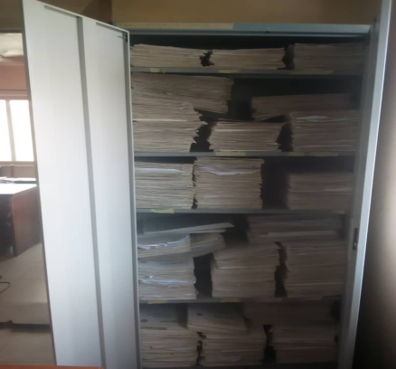

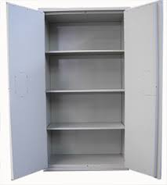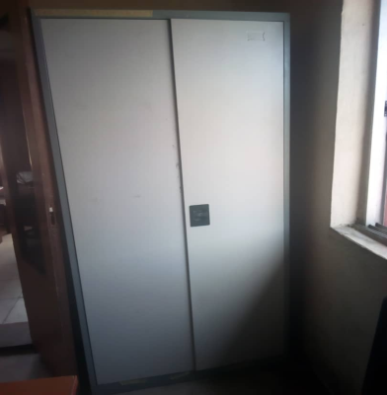

Additional Information
- We are statutorily required to deduct 5% withholding tax from all payments made to vendor which will be remitted to GON using your TIN
- We are exempted from paying VAT as an NGO, so do not include or bundle VAT in your quotes
- For this particular RFQ, you should be able to deliver 100% within 5 working days from the signing of LPO if you are selected
- Payment for this RFQ will be made 100% only after 100% successful delivery of goods
- ARFH reserves the right to cancel this RFQ at anytime without incurring any liability as long as an LPO has not been issued
- Due to the volume of applications received, only successful bidders shall be notified about the status of their bids; and asked to sign an LPO with ARFH.
- Respond to this RFQ by mailing your BIDS in sealed envelopes to: The Procurement Committee, ARFH ICHSSA Project, 16 Colin Onabule Street, off CMD Road, Lagos using this RFQ document as a template of response; any other format will lead to disqualification. Vendors are encouraged to bid for ALL the lots, though ARFH may share the lots between vendors.
- Submissions made after the RFQ closing date will not be considered.
- For more information about this RFQ, please send an email to procurements.ichssa@arfh-ng.org before the closing time of this RFQ

