REQUEST FOR QUOTATION – MEDICAL AND HEALTH RELATED CONSUMMABLES AND EQUIPMENT (RFQ NO: ARFH-LAG-20220412)
Request for Quotation
RFQ NO: | ARFH-LAG-2022042
Date: | April 12 2022
Reply to: | Sealed Bids to: THE PROCUREMENT COMMITTEE, ARFH ICHSSA-2 PROJECT.
Vendors Company Name:
Vendors Company Representatives Name:
Vendors Company Address:

Vendors Company Telephone Numbers:
Vendors Company E-mail:
Vendors Company TIN:
Vendors Company/Owner Nationality:
Vendors Expected Delivery Date:
Delivery Location: | ARFH Lagos Office, No 16 Collins Onabule Crescent, Diamond Estate, off CMD Road, Magodo Lagos.
ANTI CORRUPTION NOTICE  Under no circumstances are commissions or undisclosed rebate payments to ARFH Staff be made or authorized. No gift, gratuity, or remuneration of any kind shall be made to any ARFH Staff as a result of this request. |  | Indicate Yes or No to the Questions Below
 |  | Are products readily available for delivery in the right quantity?
 |  | Is your quotation valid for a period of 90 days?
 |  | Can you deliver within 21 days of award?
 |  | Warranty period not less than 1 year?
 |  | Do you have a relative that is a staff of ARFH?
 |  | If yes, please state name for ref purposes.
Indicate Product Origin (Country of Manufacture):
ARFH Payment Terms: | 100% after satisfactory execution of award.
RFQ Evaluation Criteria: | Cost: 40%  Validity of Quote: 10%  Warranty on Products: 20%  Evidence of Previous Work: 30%
RFQ Closing Date: | April 25 2022, 1700 HRS GMT+1

Introduction and Purpose
Association for Reproductive and Family Health (ARFH) is one of the leading Nigerian Non-Governmental Organizations implementing programs for improving Reproductive Health and Family planning (RH/FP), Care and Treatment of HIV/AIDS, Tuberculosis (TB) and Malaria etc. ARFH, under a USAID funded OVC project: Integrated Child Health and Social Services Award (ICHSSA) in Lagos and Edo States requests quotes for the supply of medical and health related consumables/equipment to be used on the Project in Lagos and Edo States.
Submission Requirements
The bidder’s quote must provide a detailed response and supporting documentation, where requested, to each of the following areas:
- The bidder must acknowledge this RFQ front page and enclose a copy of same along with other documents deemed relevant.
- All submissions must be received by the due date of the RFQ, April 25 2022. Please ensure you or proxy sign the RFQ delivery list at the office.
- Indicate clearly the RFQ Number on the Envelope.
Items to be procured
SN | Item | Qty | Unit Cost | Total Cost
1 | Camry Model, Analogue Bathroom weighing Scales | 21 units |  |  | 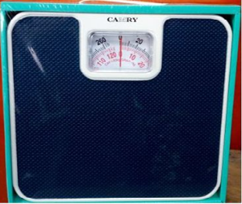
2 | MUAC TAPE/SHARKAR'S STRIP | 194 units
3 | Tape Rule | 480 units
4 | Stadiometer (Weight plus height check) | 7 units |  |  | 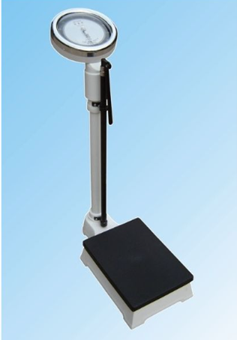

Proposal Format
In order for ARFH to conduct the most efficient quote evaluation, bidders are required to organize their proposals as noted below:
- Cover Page
- Cost being offered for goods
- Contact details of authorized representative
- Evidence of similar jobs
- Declaration of warranty on equipment/devices

Proposals must be organized according to the submission requirements and proposal format above. Proposal should be straightforward, concise and provide “layman” explanations of technical terms that are used. Emphasis should be concentrated on conforming to the RFP instructions, and responding to the RFQ requirements. Proposals which fail to address each of the submission requirements above may be deemed non-responsive and will not be further considered. Note that responses to RFQ requirements must be specifically answered within the context of the submitted proposal.

Proposal Evaluation
ARFH is committed to a transparent process of award and selection of a Vendor. An evaluation team will review, in detail, all proposals received to determine the best value.
The following parameters will be used in evaluating the Proposal:
- Cost 40%
- Validity of Quote 10%
- Warranty on Products 20%
- Evidence of previous Work 30%

Important Information
For more information about the specifications of the items being quoted for, please contact the focal person for this RFQ – Mrs Ada Onuora on 08024271498 on weekdays between 9am and 5pm. Please direct all technical enquiries about this RFQ to Mrs Onuora.

Discretion
ARFH may, at its sole discretion and after the evaluation process, choose not to issue any agreement/contract as a result of this process.
ARFH may also, at its sole discretion, choose to issue as many or as few agreements as deemed necessary to meet ARFH’s business needs.
Offers/Quotations Prices must be inclusive of all costs, and should be in NGN.
Quotes and prices should remain valid for ninety (90) calendar days from closing date of advert.
There is no reimbursement for costs associated with preparing or submission of proposals in response to this RFQ or costs associated with possible award negotiation.
ARFH may choose to work outside the Proposal Evaluation timelines without incurring any liability.

Eligibility to Bid
Only Vendors who submitted pre-qualification documents during the last Expression of Interest, and have been registered on the ARFH ICHSSA Vendor List, are eligible to bid for these items. Please continue to check the ARFH website for more details.

Submission of Proposals & Closing Time
Please submit Hard Copies of proposals IN SEALED ENVELOPES to the ARFH Procurement Committee at ARFH Lagos Office, Plot 16 Colins Onabule Crescent, Diamond Estate, off CMD Road, Magodo Lagos. Proposals are due by April 25 2022, 1700 HRS GMT+1. Proposals must be submitted by the date and time specified above.
Anti-Corruption Notice
Under no circumstances whatsoever are commissions or undisclosed rebate payments to ARFH Staff or proxies be made or authorized. No gift, gratuity, or remuneration of any kind shall be made to any ARFH Staff as a result of this request.

